Tight Rope Versus Screw Fixation in Ankle Syndesmotic Injuries
ABSTRACT:
Background; Tibiofibular diastasis can be found in ankle fractures and it may be the cause of ankle instability. Aim: to compare the accuracy and maintenance of syndesmotic reduction using tightrope fixation versus syndesmotic screw fixation and their correlation with clinical outcome. Methods; 40 patients with syndesmotic injuries who were evaluated before and after fixation by screw (Group A) and by Tightrope (Group B) in the period between November 2016 and January 2019. Exclusion criteria were patients with diabetes mellitus, neuropathic arthropathy or elderly patients with severe osteoporosis. This study included 40 patients with disrupted inferior tibiofibular syndesmosis in addition to malleolar fractures. Results: The mean age of the patients was 33.5years.the percentage of males was 77.5% and of females was 22.5%. According to Denis-Weber classification; 6 fractures (15%) were of type B while 12 fractures (30%) were of type C and there were 22 patients (55%) with isolated syndesmotic disruption. Half of the patients were treated using syndesmotic screw, and the other half with tightrope the mean American Orthopaedic Foot and Ankle Score was 91.5. The overall results were considered as satisfactory in 38 (95%) patients; 33 (82.5%) were excellent and 5 (12.5%) were good and only two (5%) patients were unsatisfactory, the two were fair, no patients were considered as poor. Conclusion; Tightrope provides a valid option for the treatment of tibiofibular diastasis. It is simple, safe and effective with no secondary surgery for removal of syndesmotic closure procedure in comparison for screw removal mentioned in the literature.
Keywords: syndesmosis, screw, tightrope, surgery, comparative.
INTRODUCTION
A syndesmosis is defined as a fibrous joint in which two adjacent bones are linked by a strong membrane or ligaments. This definition also applies for the distal tibiofibular syndesmosis, which is a syndesmotic joint formed by two bones and four ligaments. ⁽¹⁾ Traumatic injuries to the distal tibiofibular syndesmosis commonly result from high-energy ankle injuries. They can occur as isolated ligamentous injuries and can be associated with ankle fractures. ⁽²⁾ Traditionally, this has been achieved with screw fixation but controversy exists with regard to the size and number of screws, number of cortices engaged, level of screw placement above the tibial plafond, need for routine removal and the timing of the screw removal. ⁽³⁾ Problems associated with syndesmosis screw fixation include screw loosening, breakage, stiffness, prolonged period of protected weight bearing, need for second operation and the risk of late diastasis after early removal or breakage of the screw. ⁽³⁾ Tightrope is another technique for syndesmosis fixation. It comprises of a non-absorbable FibreWire held tight between two cortical metal buttons. ⁽³⁾The tightrope method provides flexible fixation of syndesmosis, quick performance, minimally invasive with reproducible results, it also obviates the need for routine removal of the implant, allows early weight bearing and ultimately get back to activities of daily living, Sports and work in a short period of time. ^{(7,8,6)} Problems associated with the tightrope method include soft tissue complications as soft tissue irritation, wound breakdown and knot prominence necessitating implant removal , syndesmotic widening , late diastasis and synostosis . ^{(3, 4)}
PATIENT AND METHODS
A prospective analysis of 40 patients with syndesmotic injuries were evaluated before and after fixation by screw (Group A) and by Tightrope (Group B), the first case was managed in November 2016 and the last case was done in January 2019, all cases were managed in king Abdul Aziz Hospital, KSA and Benha University Hospitals, Egypt. Inclusion criteria were patients with syndesmotic disruptions either isolated or associated with ankle fractures with good bone quality at ages of 18 – 50 years old. Exclusion criteria were patients with diabetes mellitus, neuropathic arthropathy or elderly patients with severe osteoporosis.
Demographic and clinical data were recorded as follows: age, sex, side affected, occupation, mechanism of injury, classification of fractures, tibiofibular displacement, talar displacement, time lapse before surgery, and follow up period, each patient in this study was carefully assessed radiologically and clinically by taking a detailed clinical history and general and local examination of the injured patient.
Operative procedure:
All cases were performed in supine position under spinal anaesthesia on operative tables which were translucent to x rays, all cases were performed with use of a carefully padded thigh tourniquet and utilizing AO technique.
Group A: The longitudinal lateral incision in line with the fibula is the standard approach for most of the cases in our study, a 10-15 cm incision done in line with the fibula starting proximally, if necessary, continue distally a further 2 cm curving slightly anteriorly in relation to the tip of the lateral malleolus in order to increase exposure and release tension.
Superficial surgical dissection: The dissection plane is between the peroneus tertius anteriorly and peroneus longus and brevis posteriorly, avoiding damage superficial peroneal nerve also taking care of the short saphenous vein and sural nerve when dissecting posteriorly.
Deep surgical dissection: Free the periosteum at site of plate application, in cases of isolated syndesmosis injury, without unnecessary stripping of the periosteum to avoid affection on blood supply of the bone in cases of fracture of lateral malleolus associated with syndesmotic injury, free the periosteum at the fracture site, in order to minimize devascularisation, one third tubular plate in different lengths were used for fibular fractures fixation in our study in group A.
In group B: A needle which was attached to the Tight Rope button was then passed from the lateral side to the medial side through the drill holes and the needle passed through the intact medial skin, the oblong button (leading button) was advanced through the drill holes till it passed the medial tibial cortex, The suture which was connected to the oblong button(medially),was pulled medially in order to toggle the oblong button and aid the button to lie flush on the medial tibial cortex, Then the assembly was tensioned by pulling the free ends of fibre wire on the lateral side, once both the button were seated flush on the bone, the free ends of the fibre wire were hand tied laterally and the position of the buttons and syndesmosis reduction were confirmed by fluoroscopy after the bone clamp was removed, the ends of the medial suture were cut flush with the skin on the medial side and the ends the lateral side were cut with a 5 mm tail which lie flush along the lateral fibular side to not cause subcutaneous irritation.
Post operatively all patients given antibiotics, analgesic and followed regularly for wound care and adequacy of reduction by regular X ray
Rehabilitation
Group A: Absolute non weight bearing with below knee back splint for 6 weeks, then removal of back splint and start range of motions of the ankle joint with keeping him non weight bearing for further 6 weeks then removal of the syndesmotic screws done for most cases at 12- 16 weeks then full weight bearing has been started following screws removal.
Group B: Absolute non weight bearing with below knee back splint for 3 weeks then removal of back splint and start range of motions of ankle joint for further 3 weeks then start gradual weight bearing till full weight bearing.
The accuracy of reduction was classified on radiological basis into good, fair or poor. (Table 1)
Methods of assessment of the results: At the end of follow up (at least six month), all patients were evaluated regarding their clinical and functional outcome following the modified AOFAS Ankle-Hindfoot Scale. (Table 2)
Pain: evaluated by means of Verbal analog scale which was recorded: 1= no pain, 2= mild (pain with exertion), 3= moderate (pain with acitvity of daily life (ADL), 4=severe (limiting ADL).
Scores 80-100 were considered as an excellent result, 60-79 as good, 40-59 as fair and less than 40 as poor. Patients with excellent and good results were classified as satisfactory while patients with fair and poor results were classified as unsatisfactory. ⁽¹³⁾ (Table 3)
Methods of Statistical Analysis: Statistical analysis was carried out using SPSS statistics software version 20. Categorical variables were described using frequencies and percentages. Chi-square test, Fisher’s exact test and Monte Carlo test were used for testing associations between categorical variables. Quantitative data were tested for normality using Kolmogorov-Smirnov test. Abnormally distributed data were given as median (minimum-maximum). Non-parametric statistical test of significance was applied; Mann-Whitney test was used to compare two independent groups Statistical significance was accepted as p < 0.05. All applied statistical tests of significance were two-tailed.
Informed consent: Informed consent was taken from every patient to be involved in the study.
RESULTS
This study included forty patients with inferior tibiofibular syndesmotic disruption, twenty of them were treated using stainless steel syndesmotic screw and the other twenty were treated with tight rope fixation. The duration of follow-up ranged from six to 18 months with a mean of 10.53± 2.77 months. The results were assessed both clinically and radiologically at the end of the follow-up period. The overall results in group A were considered as satisfactory in 18 (90%) patients; 10 (50%) were excellent and 8(40%) were good and only 2 (10%) patients were unsatisfactory; the two (10 %) were fair , while in group B were considered as satisfactory in 20 (100%) patients; 17(85%) were excellent and 3(15%) were good.
The results were assessed both clinically and radiologically at the end of the follow-up period. The overall results in group A were considered as satisfactory in 18 (90%) patients; 10 (50%) were excellent and 8(40%) were good and only 2 (10%) patients were unsatisfactory; the two (10 %) were fair , while in group B were considered as satisfactory in 20 (100%) patients; 17(85%) were excellent and 3(15%) were good.
The mean time to full weight bearing was 12.85 weeks for group A (screw group) compared with 10.25 weeks for group B (tightrope group).
The mean AOFAS score in our study for tightrope group was 95 % (65-98) and the mean AOFAS score for syndesmotic screw group was 88% (65-94).
There was no significant statistical relation between the final results and the age, sex, side, occupation, mechanism of trauma, type of fracture, tibiofibular displacement, time lapse before operation, duration of follow up.
Accuracy of reduction: There was a significant statistical correlation between the accuracy of reduction and the final results. In this study, regarding the comparative preoperative and postoperative radiological measurements the mean preoperative medial clear space for group A was 4.77mm and for group B was 4.45mm The mean postoperative medial clear space for group A was 3.69mm and the mean MCS for group B was 3.42mm, the mean preoperative tibiofibular clear space (TFCS) in group A was 7.13mm while the mean TFCS in group B was 7.08 mm, The mean postoperative TFCS in group A was 2.46mm while in group B was 2.68mm, The mean preoperative tibiofibular overlap distance (TFOL) in group A was 2.38mm while was 2.12mm in group B, The mean postoperative TFOL in group A was 7.22mm while was 7.03mm in group B. The mean preoperative tibiofibular overlap was almost the same in the 2 groups being 4.70 ± 1.88 mm ranging from 0 to 8 mm and the mean preoperative medial clear space was 3.95 ± 2.38 mm ranging from 2 to 10mm. Postoperatively, the mean tibiofibular overlap was 9.55 ± 1.93 mm ranging from 3 to 11 mm and the mean medial clear space was 2.70 ± 1.20 mm ranging from 2 to 6 mm. In the present study 28 (70%) patients had good reduction, 14 patients (35%) were in group A and 14 patients (35%) were in group B patients, 11patients (27.5%) had fair reduction 5 (12.5) in group A, and 6 patients (15%) in group B while only one patient had poor reduction which was in group A. There was one patient in group B with unsatisfactory result, although the accuracy of reduction was graded as fair while the other one has unsatisfactory possibly due to poor reduction.
Case 1: 31 male patient has isolated syndesmotic injury managed by two tightrope fixation. Figure 4
Case 2: 18 year old male patient has isolated syndesmotic injury managed by two syndesmotic screws figure 5
DISCUSSION
Injuries to the ankle may involve the inferior tibiofibular syndesmosis and can lead to less than favorable long term outcomes if not properly diagnosed and managed, Ebraheim reported that 8% of all ankle fractures have syndesmosis disruptions and this kind of injury should receive special care due to the increased risk of associated complications. ⁽⁵⁾ Burns reported that a complete disruptions of the syndesmosis can lead to a 39% decrease in tibiotalar contact area and a 42% increase in tibiotalar contact stress. ⁽⁶⁾ Our study was on this type of injuries which was either isolated syndesmotic injuries or associated with ankle fractures. It has been reported in the literature that the evaluation of the syndesmosis without diastasis should involve a tibiofibular clear space of less than 6 mm on anteroposterior radiographs, a medial clear space of less than 5 mm on AP radiographs, a tibiofibular overlap of greater than 6 mm on AP radiographs and greater than 1 mm in mortise view. This guideline was aimed to aid in assessing disruption of syndesmosis as well as postoperative reduction. Measurements are made 1cm proximal to the tibiotalar joint line, as we did in our study. There remains controversy regarding the standard surgical treatment of the syndesmotic injuries as well as the indications of syndesmotic fixation. Traditional transfixation of the tibia and the fibula with screws as recommended by the AO group has been the standard treatment. In addition, the size of the screws, number of the cortices engaged as well as distance from the joint that the screws are placed are controversial. The most common complications associated with conventional treatment with screws include breakage of the screws and hardware pain. Full weight-bearing can result in breakage or loosening of syndesmotic screws, stiffness, as well as a need for a second surgery to remove the internal hardware. Tightrope is a relatively new surgical technique based on the suture endobutton design. With this technique, the surgeon is able to avoid many of the complications associated with the use of traditional screw fixation, specifically screw breakage, stiffness from over constraint of the syndesmosis and hardware pain. ⁽³⁾Thornes tested a suture endobutton construct in cadaveric limbs utilizing AO syndesmotic screws fixation as a comparison. Diastasis of the syndesmosis was created in the limbs by applying an external rotation force. The suture endobutton construct was compared to a single four cortices 4.5 mm AO screw fixation. No significant differences were observed in the mean rate of failure between the two groups. Cottom et al stated the endobutton did give a significantly more consistent performance and demonstrated higher standard deviation values. ⁽⁷⁾ ⁽⁸⁾Thorns reported that the problem with the screws fixation is that it provides rigid fixation to a joint where movements naturally occurs and also there are other problems like screw loosening, breakage and need for removal. Close stated that syndesmosis allows ankle mortise flexibility due to the elastic nature of the ligaments. Therefore, the intermalleolar distance is able to fluctuate and allows for tibial and fibular rotation with range of motion of ankle joint. Tightrope allows for stability in syndesmosis with the implant remaining in place till full ligament healing is achieved with semi-rigid dynamic stabilization. ⁽⁷⁾ ⁽⁹⁾
This study traced 40 patients had unstable ankle fractures with inferior tibiofibular ligament injuries, The target was to compare the accuracy and maintenance of syndesmotic reduction using tightrope fixation versus syndesmotic screw fixation and their correlation with clinical outcome.
The overall results in group A were considered as satisfactory in 18 (90%) patients; 10 (50%) were excellent and 8(40%) were good and only 2 (10%) patients were unsatisfactory; the two (10 %) were fair , while in group B were considered as satisfactory in 20 (100%) patients; 17(85%) were excellent and 3(15%) were good, The mean time to full weight bearing was 12.85 weeks for group A (screw group) compared with 10.25 weeks for group B (tightrope group), the mean American Orthopaedic Foot and Ankle Scale score for group A (screw group) was 88% while it was 95 % in group B (tightrope group), according to our criteria of malreduction, one case of malreduction (5%) were identified in the syndesmotic screw group, whereas there were no cases of malreduction were identified in tightrope group, regarding other complication, in screw group there were 2 cases (10%) of breakage of screws, two cases (10%) of late diastasis, one case of hyperesthesia(5%) and 3 cases of ankle joint stiffness (15%), while in tightrope group, there were 2 cases (10%) of prominent knot not necessitating surgical removal, one case (5%) of late diastasis, two cases (10%) of hypersthesia and 2 cases (10%) of ankle joint stiffness.
The results of our study as shown above show that the Tightrope fixation was a significantly better functionally than screw fixation and these results are comparable with the results of Naqvi GA; et al. who made a study on 46 patients with syndesmotic diastasis between July 2007 and June 2009; 23 patients of them treated by tightrope and 23 patients treated by syndesmotic screws and they found that the Tightrope fixation was significantly better at maintaining the reduction even after a mean duration of 30 months after surgery, the mean time to full weight bearing in our study was 12.85 weeks for group A (screw group) compared with 10.25 weeks for group B (tightrope group) while in the study of Naqvi GA; et al the mean time to full weight bearing was 9.1 weeks in the syndesmotic screw group and was 8 weeks in the Tightrope group. ⁽¹⁹⁾ the mean AOFAS score in our study for tightrope group was 95 % (65-98) and the mean AOFAS score for syndesmotic screw group was 88% (65-94) while in the study of Naqvi GA; et al the mean AOFAS score in tightrope group 89.56.+8.6(69-100) and the mean AOFAS score in syndesmotic screw group 86.52+9.6(65-100). ⁽³⁾ In the present study 28 (70%) patients had good reduction, 14 patients (35%) were in group A and 14 patients (35%) were in group B patients, 11patients (27.5%) had fair reduction 5 (12.5) in group A, and 6 patients (15%) in group B while only one patient had poor reduction which was in group A, there was one patient in group B with unsatisfactory result, although the accuracy of reduction was graded as fair while the other one has unsatisfactory possibly due to poor reduction, there was a significant statistical correlation between the accuracy of reduction and the final results. Leeds and Ehrlich demonstrated that inadequate reduction of the syndesmosis led to late arthrosis and instability that correlated with poor subjective and objective results. ⁽¹¹⁾ So, in this study the syndesmotic malreduction is the only independent predictor of worse outcome, this the same proven by Naqvi GA; et al in his study. ⁽³⁾
CONCLUSIONS
Tibiofibular diastasis can be found in ankle fractures and it may be the cause of ankle instability, tightrope provides a valid option for the treatment of tibiofibular diastasis. It is simple, safe and effective with no secondary surgery for removal of syndesmotic closure procedure in comparison for screw removal mentioned in the literature.
Accurate reduction of the tibiofibular syndesmosis is essential for the final outcome of the patients, there was a significant statistical correlation between the accuracy of reduction and the final results. There was no significant statistical relation between the final results and the age, sex, side, occupation, mechanism of trauma, type of fracture, tibiofibular displacement, time lapse before operation, duration of follow up.
Sources of funding
This research did not receive any specific grant from funding agencies in the public, commercial, or not-for-profit sectors.
Conflicts of interest
No conflicts of interest
REFERRENCES
- John J Hermans, Annechien Beumer, Ton A W de Jong, Gert-Jan Kleinrensink. (2010) Anatomy of the distal tibiofibular syndesmosis in adults: a pictorial essay with a multimodality approach, J.Anat.2010 Dec: 217(6):633-645.
- Kenneth J. Hunt. (2013) Syndesmosis injuries, Curr Rev Musculoskelet Med. 2013 Dec: 6 (4):304-312.
- Gohar A. Naqvi, Aseer Shafqat, Nisir Awan. (2012) Tightrope fixation of ankle syndesmosis injuries: Clinical outcome, complications and technique modification, int. J. care injured. 2012; 43; 838-842.
- Treon K, Beastall JE, Kumar K, Hope MJ. (2011) Complications of ankle syndesmosis stabilisation using a tightrope. In Orthopaedic Proceedings J Bone joint Surg Br. 2011 Jan; 93 (No. SUPP_I, pp. 62-62).
- Ebraheim NA, Lu J, Yang H, Mekhail AO, Yeasting RA.(1997) Radiographic and CT evaluation of tibiofibular syndesmotic diastasis: a cadaver study. Foot & ankle international. 1997 Nov; 18(11):693-8.
- Burns WC, Prakash K, Adelaar R, Beaudoin Krause W. (1993)Tibiotalar joint dynamics: Indications for the syndesmotic screw- a cadaver study. Foot Ankle Int. 1993; 14; 153-158,
- Thornes B, Walsh A, Hislop M, Murray P, O'Brien M. (2003) Suture-endobutton fixation of ankle tibio-fibular diastasis: a cadaver study. Foot & ankle international. 2003 Feb; 24(2):142-6.
- Cottom, James M, Christopher F, Hyer, Terrence M: (2008) Treatment of syndesmotic distruptions with the arthrex tightrope. Foot Ankle Int. 2008 Aug; Vol. 29, No.8.
- Close, JR (1956) Some applications of the functional anatomy of the ankle joint. J bone joint surg. 1956; 38A: 761-781.
- Naqvi GA, Cunningham P, Lynch B, Galvin R, Awan N. (2012) Fixation of ankle syndesmotic injuries: comparison of tightrope fixation and syndesmotic screw fixation for accuracy of syndesmotic reduction. The American journal of sports medicine. 2012 Dec; 40(12):2828-35.
- Leeds HC, Ehrlich MG. (1984) Instability of the distal tibioﬁbular syndesmosis after bimalleolar and trimalleolar ankle fractures. J Bone Joint Surg Am 1984; 66(4): 490-503.
- Grass R, Herzmann K, Biewener A, Zwipp H. (2000) Injuries of the inferior tibiofibular syndesmosis. Unfallchirurg 2000; 103(7): 520-32.
- Hoiness P, Stromsoe K.(2004) Tricortical versus quadricortical syndesmosis fixation in ankle fractures: A prospective, randomized study comparing two methods of syndesmosis fixation. J Orthop Trauma 2004; 18 (6): 331-7.

Table 1: Criteria of reduction. ⁽¹²⁾
Score | Anatomical results of reduction
Good | - Normal or up to two mm of anterior, posterior or distal displacement of the medial malleolar fragment.  - Up to two mm of displacement of the lateral malleolar fragment in any direction.  -Tibiofibular overlap > nine mm or medial clear space < three mm.
Fair | -Anterior, posterior or distal displacement of the medial malleolar fragment of two to five mm.  -Displacement of the lateral malleolar fragment of two to five mm.  -Minimum or questionable joint damage shown by irregularity of the articular surface on the x-ray or at the time of surgery.  -Tibiofibular overlap of six to nine mm or medial clear space of three to five mm.
Poor | -Medial malleolar fragment displacement more than five mm.  -Any lateral tilt, shift, or rotation of the medial malleolar fragment.  -Displacement of the lateral malleolar fragment more than five mm.  -Severe joint damage shown by irregularity of the articular surface.  -Tibiofibular overlap < six mm or medial clear space > five mm.

Table 2: Modified AOFAS Clinical Rating System (Ankle-Hindfoot Scale). ⁽¹³⁾
CATEGORY | VARIABLE | SCORE
Pain (40 points) | - None | 30
 | - Mild, occasional | 20
 | - Moderate, daily | 10
 | - Severe, almost always present | 0
Function (50 points)
1) Activity limitations, support requirements | - No limitations, no support | 10
 | - No limitation daily activities, limitation of recreational activities, no support | 7
 | - Limited daily & recreational activities, care | 4
 | - Severe limitation daily & recreational activities, walker, crutches, wheelchair, brace | 0
2) Maximum walking distance, blocks | - > 6 | 5
 | - 4-6 | 4
 | - 1-3 | 2
 | - <1 | 0
3) Walking surfaces | - No difficulty on any surface | 5
 | - Some difficulty on uneven terrain, stairs, inclines, ladders | 3
 | - Severe difficulty on uneven terrain, stairs, inclines, ladders | 0
4) Gait abnormality | - None, slight | 8
 | - Obvious | 4
 | - Marked | 0
5) Sagittal motion (flexion + extension) | - Normal/mild restriction (≥30°) | 8
 | - Moderate restriction (15-29°) | 4
 | - Severe restriction (<15%) | 0
6)Hindfoot motion (inversion + eversion) | - Normal/mild restriction (75-100% normal) | 6
 | - Moderate restriction (25-74% normal) | 3
 | - Marked restriction (<25% normal) | 0
7) Stability (anterior-posterior, varus-valgus) | - Stable | 8
 | - Definitely unstable | 0
Alignment (10 points) | - Good, plantigrade foot, ankle-hindfoot well aligned | 10
 | - Fair, plantigrade foot, some degree of ankle-hindfoot malalignment observed, no symptoms | 5
 | - Poor, non plantigrade foot, severe malalignment, symptoms | 0
Tibiofibular displacement  (10 points) | tibiofibular overlap > 9 mm or medial clear space < 3 mm  - tibiofibular overlap 6-9 mm or medial clear space 3-5 mm | 10
 |  | 5
 | - tibiofibular overlap < 6 mm or medial clear space > 5 mm | 0
TOTAL |  | 100

Table 3: Relation between score and results. ⁽¹³⁾
Score | Grade | Satisfaction
80-100  60-79 | excellent  good | satisfactory
40-59 | fair | unsatisfactory
< 40 | poor

Table (4): Relation between the results and the type of the fixation
 | Group A |  | Group B
 | Number | Percent | Number | Percent
Satisfactory | 18 | 90% | 20 | 100%
Unsatisfactory | 2 | 10% | - | -
Total | 20 | 100% | 20 | 100%

Figure 1: Relation between the results and the type of the fixation

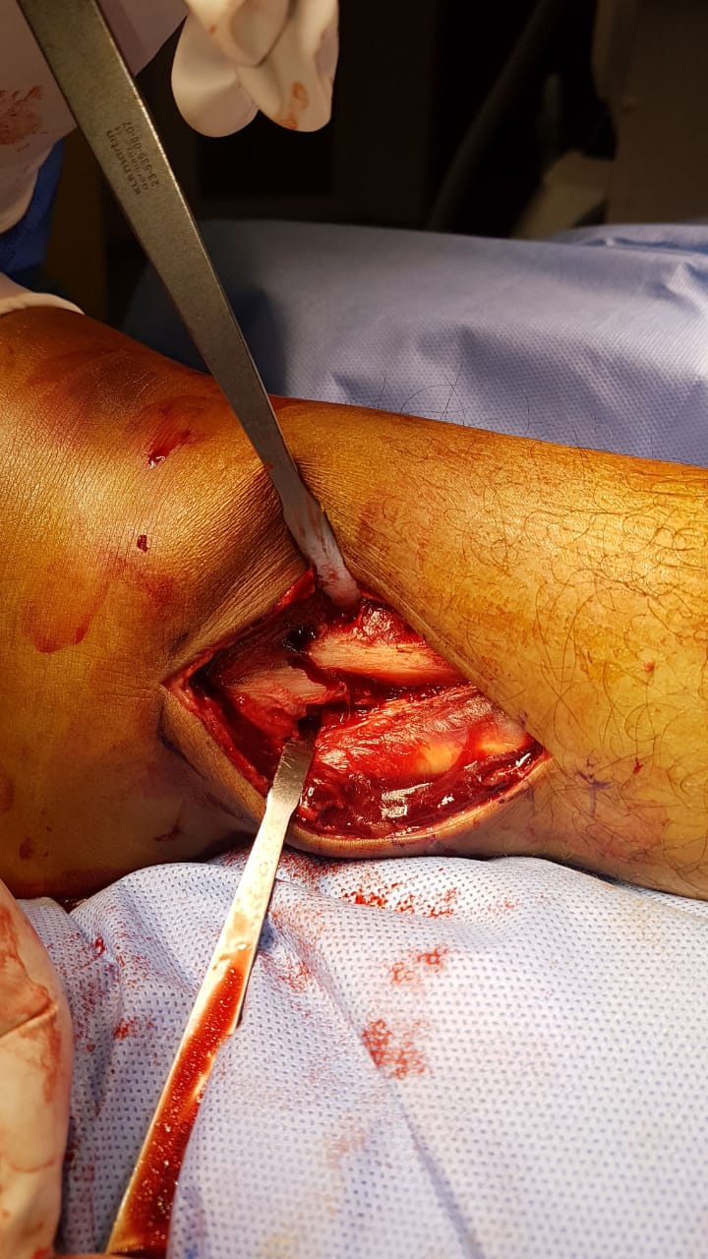
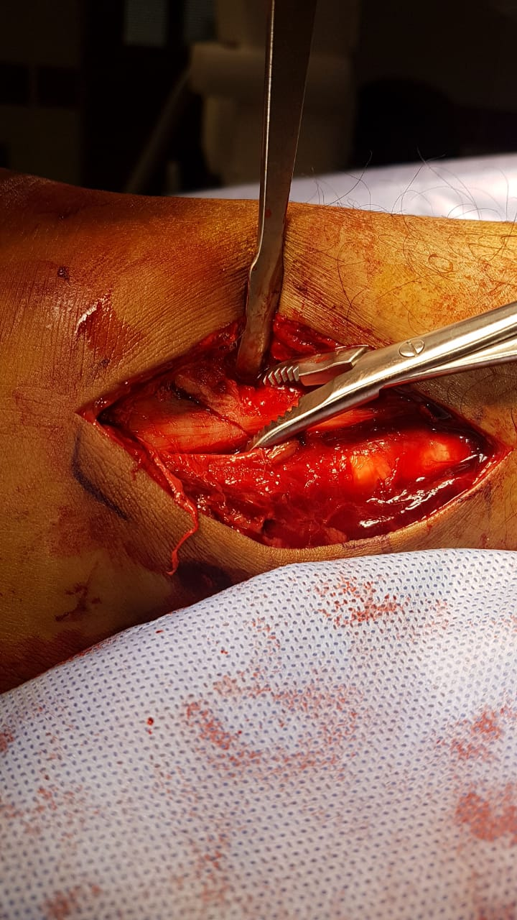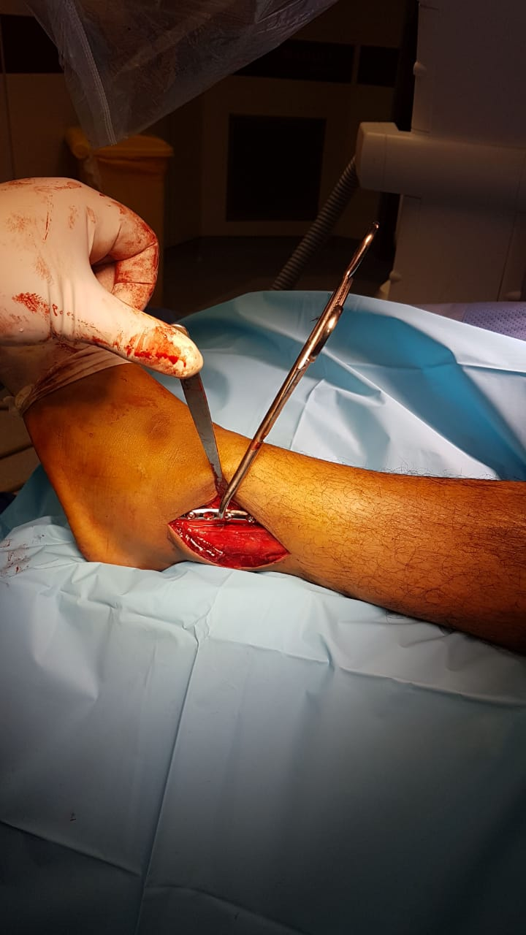
Figure (2): Operative procedures in group A

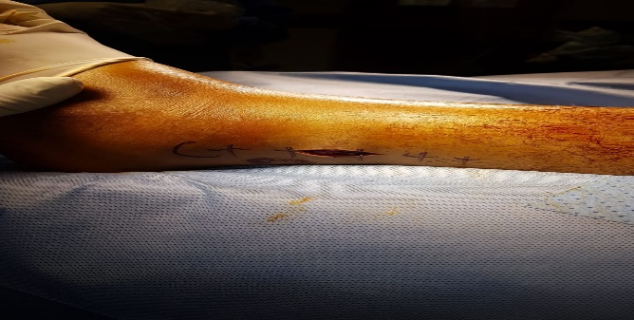
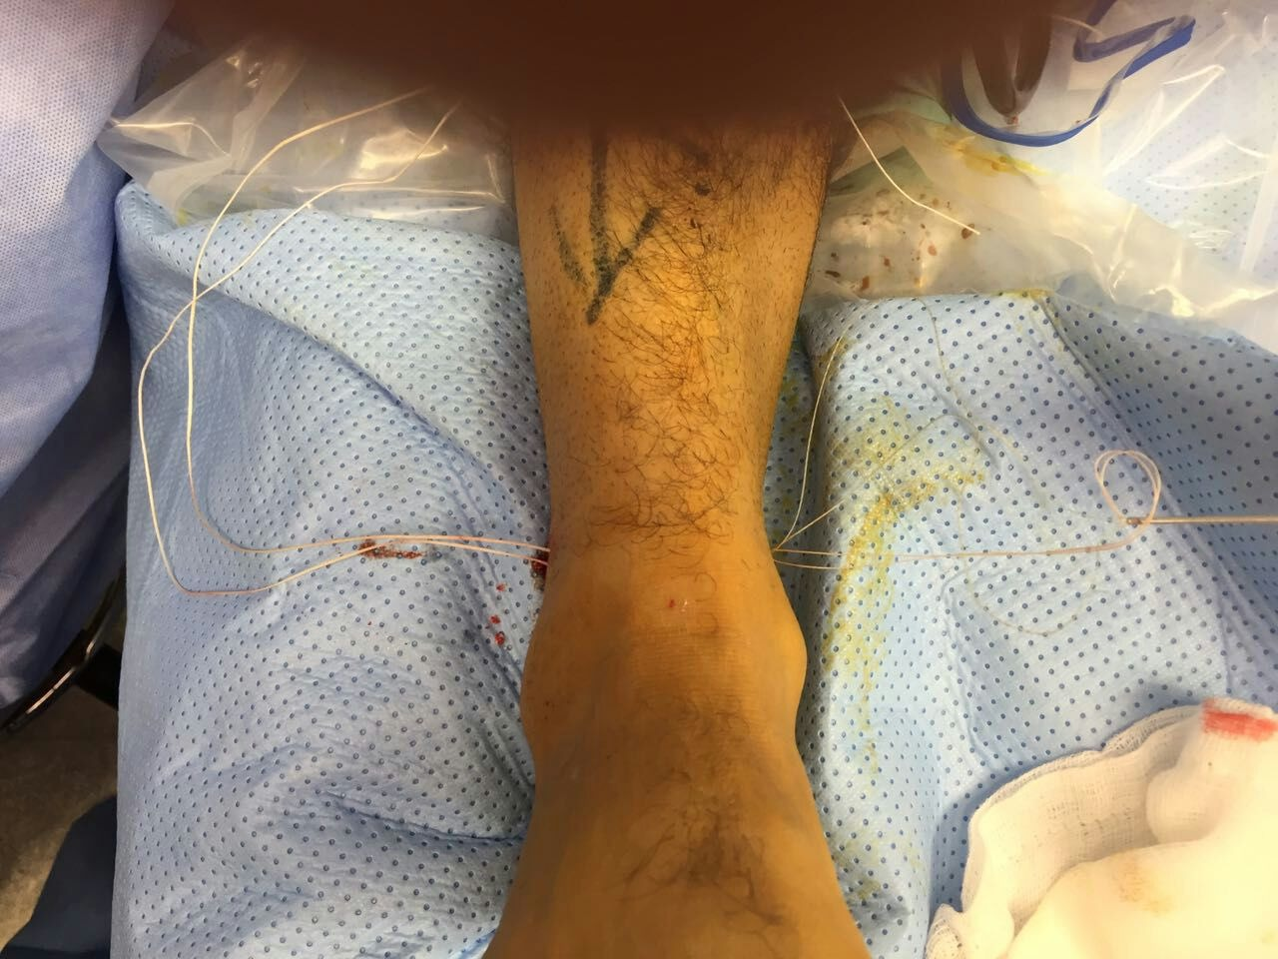
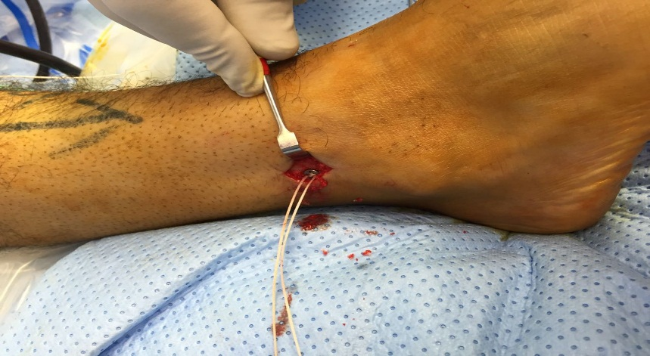
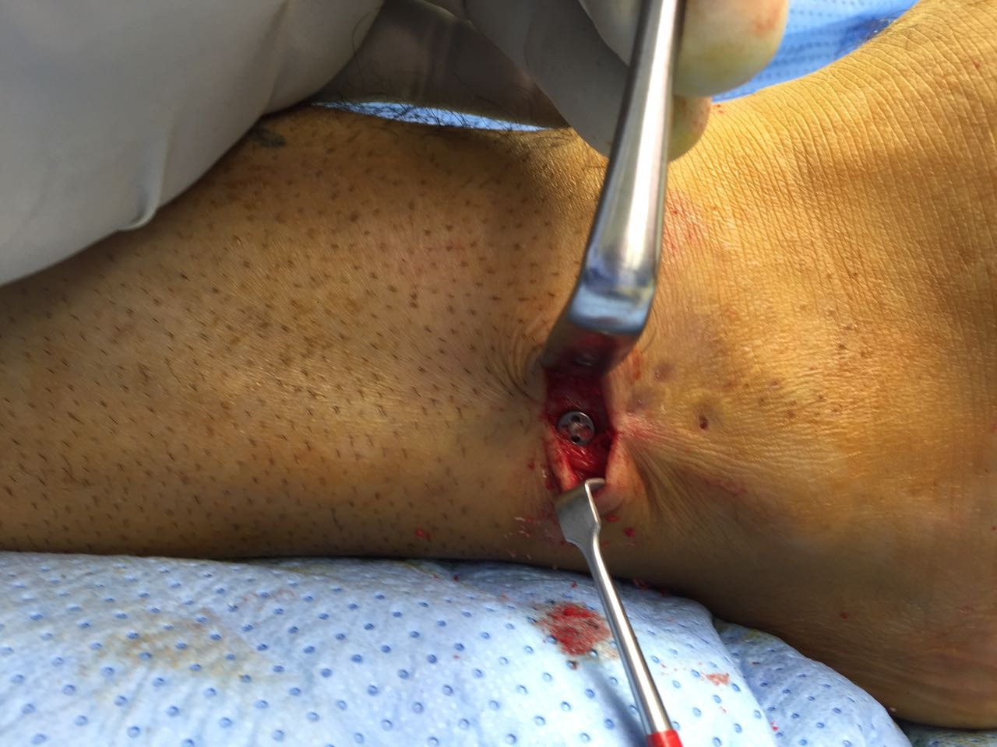
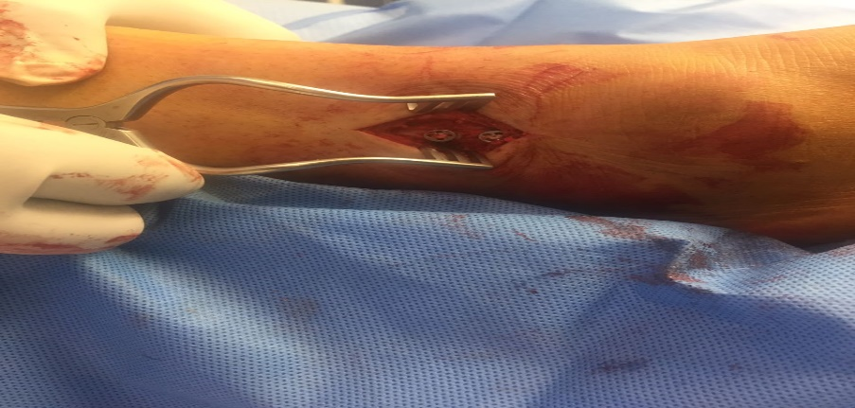
Figure (3): Operative procedures in group B
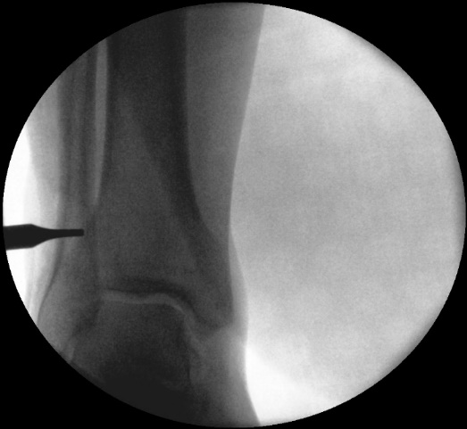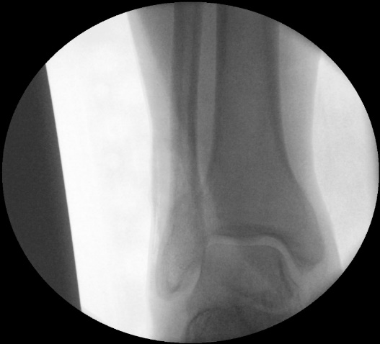
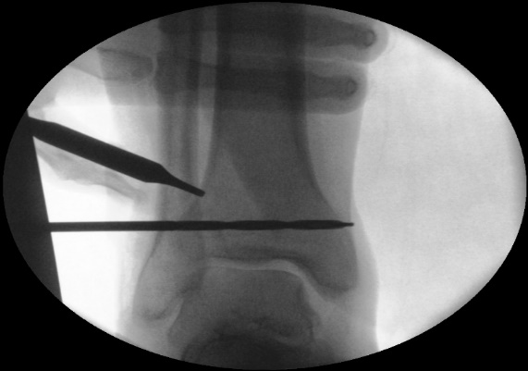
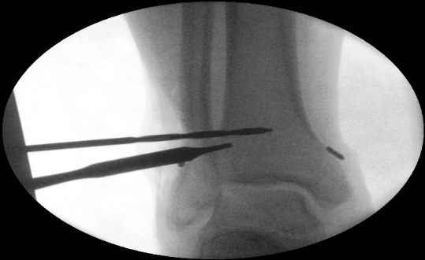
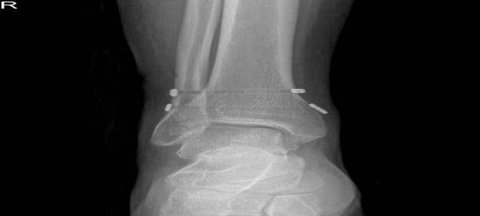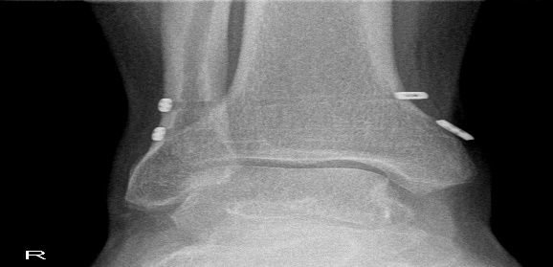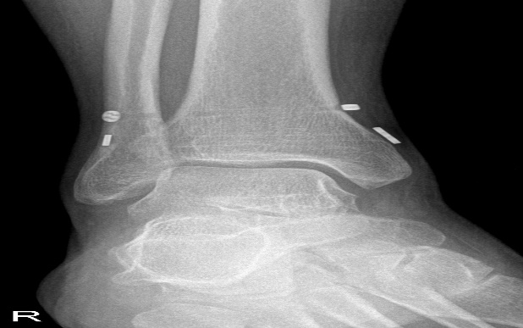
Figure (4): Intraoperative and postoperative follow up x ray

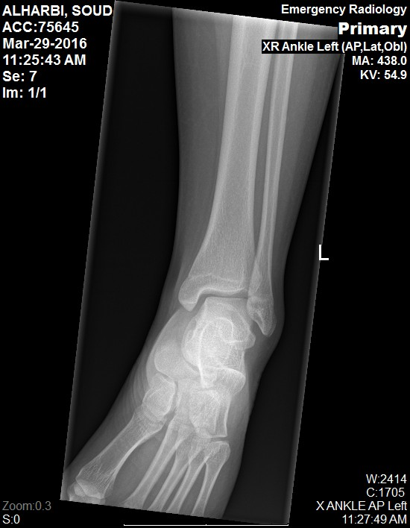
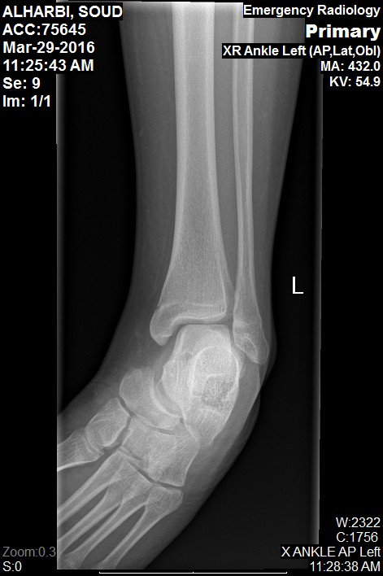
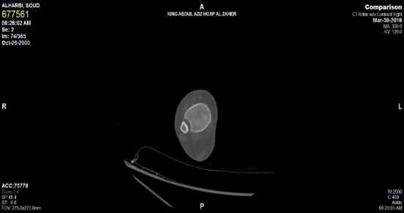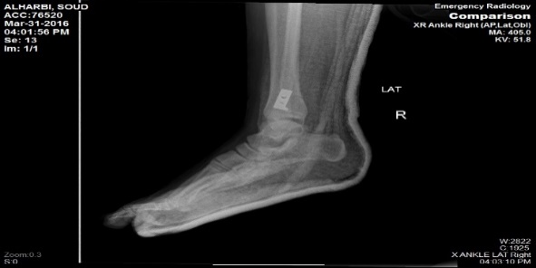
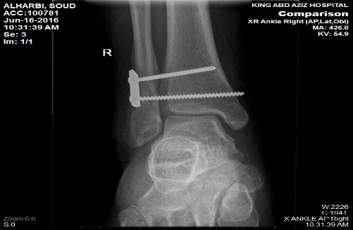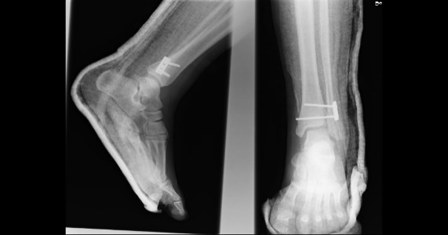

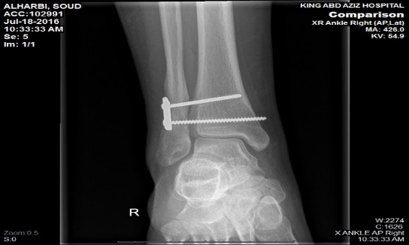
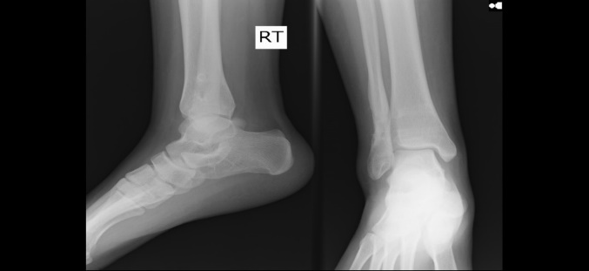
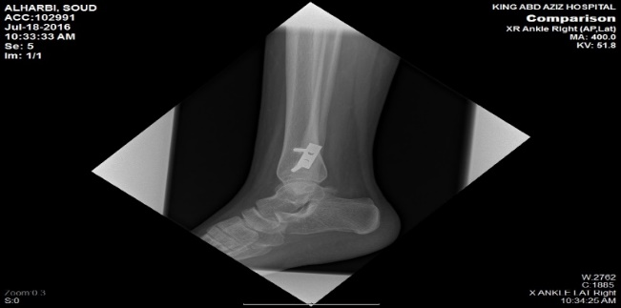

Figure (5): Preoperative, postoperative follow up and post removal x rays

